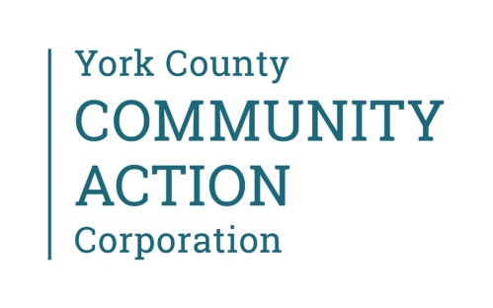 June 7, 2021

As we are aware, many staff may be planning to travel during the summer months. We want to educate staff of the current US and Maine CDC travel guidelines. YCCAC continues to follow and practice the guidelines set forth by the US and Maine CDC in regards to the health and safety of our patients, clients and of course, staff. The current guidelines for travel are included below.

For visitors traveling from out of state or Maine residents traveling to other states:
- As of May 1, 2021, Maine moved to an “All states exempt unless specified” approach. This means that travelers from or returning from exempt states are not required to test or quarantine upon arrival.
For international travelers coming to Maine:
Staff who travel outside of the United States should report those plans to HR. Return to work practices in those cases will be based on Maine and US CDC guidance for the country(ies) in question.
For non-healthcare worker fully vaccinated travelers (at least 14 days past their final COVID-19 dose):
- Quarantine is not required unless you are experiencing symptoms.
- Testing is recommended 3-5 days after arrival in the US.
  - If the COVID-19 test is positive, isolate.
For those travelers who are non-healthcare workers and not fully vaccinated and who arrive in Maine within 7 days of entering the United States:
- Quarantine for 7 days from arrival in the US AND get a COVID-19 molecular or antigen test 3-5 days after arrival in the US.
- If the COVID-19 test is positive, isolate.
- Even if the COVID-19 test is negative, complete the 7-day quarantine after travel.
- If individuals arriving from international travel do not get a COVID-19 test after their arrival, they should quarantine for 10 days after their arrival in the US.
- Avoid being around anyone who is at increased risk of severe COVID-19 illness for 14 days following arrival in the US, regardless of COVID-19 test results.
For further information, please visit: Maine.gov website: https://www.maine.gov/covid19/

